**Indoor/outdoor settings**

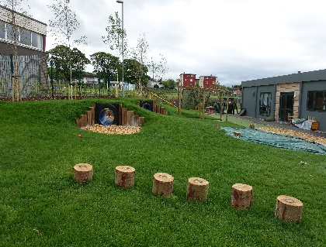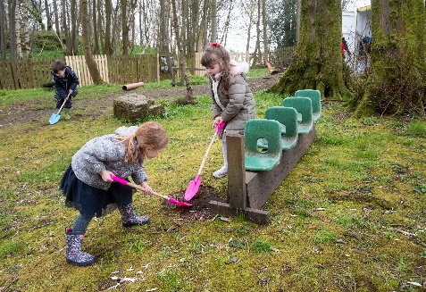 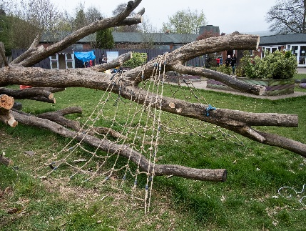

This model is as an indoor setting but where the scale and quality of the outdoor space is appropriate for enhancing the child’s quality of play and learning experiences and is suitable to register additional capacity and high quality natural outdoor spaces when combined with the indoor space. Both indoor and outdoor areas will be accessible to children 100% of the operational time.

An additional condition is added to the registration to reflect the setting is an indoor/outdoor setting.

**Settings**

Aboyne Primary School Nursery

Auchinairn Early Years Centre

Auchterhouse Nursery

Balmalloch Nursery

Cairellot Nursery Ltd

Castlegate Nursery & Out of School Club Limited

Castlemilk Day Nursery

Caz's Kiddies In The Country

Clentry Nursery School

Cornerstones Nursery

Darvel Early Childhood Centre

Dreams DayCare Limited

Drumfork Nursery and Family Centre

Glenpark Children’s Centre

Gryffe Manor Nursery

[Happy Days at Hardengreen](mailto:Happydays@Hardengreen)

Houston Early Learning and Childcare Class

Hythehill Primary School Nursery

Holm Early Learning and Childcare Centre

Inverarity Pre School Class

Kidstore Childcare Ltd

Kilmaurs Early Childhood Centre

Kirklandneuk Early Learning and Childcare Centre

[Kirktonholme @ Canniesburn](mailto:Kirktonholme@canniesburn)

[Kirktonholme @ Newton Mearns](mailto:Kirsonholem@Newton%20Meanrts)

KLAS Care

Lenzie Meadow Early Years

Little Hands Nursery Centre

Little Stars Alloa

Lochfield Early Learning and Childcare Centre

Murroes Pre School Class

Nether Robertland Early Childhood Centre

Netherthird Early Childhood Centre

Parkview Nursery

Rainbow Nursery – Paisley

Rocking Horse Nursery – Aberdeen

Rothes Primary School Nursery

Rowena Nursery School

Spateston Early Learning and Childcare Centre

St. Mirins Out of School Club

Sunflower Family Nurture Centre

South Lodge Primary School Nursery

The Glasgow Academy - Newlands Nursery

The Tower Nursery

Tiny Tots Nursery (Inverness)

Tip Toes Children’s Nursery

**Useful guidance**

Early Learning and Childcare: Delivering High Quality Play and Learning Environments Outdoors

<https://hub.careinspectorate.com/media/1157/delivering-play-and-learning-environments-outdoors-practice-note.pdf>