

**Self-directed Support Standard 13**

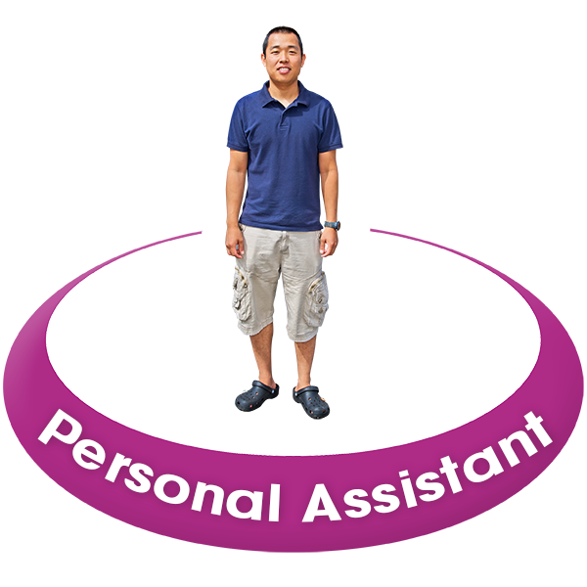**When direct payments are used to employ Personal Assistants (PAs)**

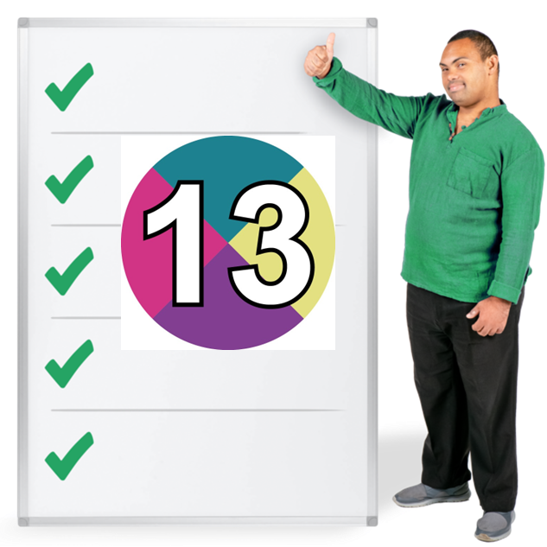

**Easy Read**



## About this document

|  |  |
| --- | --- |
| a smiling woman holding an Easy Read document | This is an Easy Read information document about new guidance called Self-directed Support Standard 13. |
| 3 people reading information | The information was written by **Social Work Scotland** with help from lots of people interested in **Self-directed Support** including people from the Personal Assistant Programme Board. |
| a man pointing with a poster behind him showing 4 choicesa calendar with a circle around 1 daycouncil staff in a council building | **Self-directed Support** is when people choose how their support is organised.  There are 4 ways or ‘options’ to do this.  **Direct payments** are option 1 of Self-directed support.  In this document, **direct payments** mean money paid by a local council to a person.  The person can then pay for the support they want. |
| a man with a banner at his feet that says 'personal assistant'a wage packet with money in it | This includes employing Personal Assistants**.**  **Employ** means to choose someone to work for you and pay them a wage.  **Personal Assistants** are staff who are paid to help someone live independently and take part in community life. |

## About Standard 13

|  |  |
| --- | --- |
| A young woman smiling and holding an Easy Read document.**A woman with her arm out to reveal a large opening page with the number 12 on it.** | There are 12 Self-directed Support Standards.  These are 12 important things that local councils will work on to make all the options of Self-directed Support better.  You can read about the 12 Self-directed Support Standards in this [Easy Read document](https://hub.careinspectorate.com/media/5794/framework-of-standards-easy-read_pages.pdf). |
| a man and his personal assistantthe Standard 13 symbol - a white 13 on a coloured background | Standard 13 has been added now.  Standard 13 is more guidance to help make option 1 better for when people employ Personal Assistants. |
| A map of the united kingdom with Scotland highlighted in bright green. There are 3 thumbs up signs around Scotland. | The **Standards** mean that wherever in Scotland someone lives, you should be offered good support. |
| a man giving the thumbs up and holding a sign with a green tick on ita smiling woman giving the thumbs up next to a list with green ticks on it | Standard 13 says:   * what people who employ Personal Assistants should get – this is called a **Standard Descriptor** * what staff, systems and organisations will do – this is called a **Practice Statement** |

## Standard 13 – when direct payments are used to employ Personal Assistants

|  |  |
| --- | --- |
| a man and his personal assistant next to a hand holding money in notes | People who employ Personal Assistants should get from Standard 13:   * a payment of money from their local council called a direct payment |
| a thinking woman with money and a train ticket in thought bubbles above her head | * the ability to use their direct payment to buy what helps to meet their **outcomes** – what they want to happen |
| **a woman who is a wheelchair user next to an access ramp, a timer with more time on it, an easy read document and a speech bubble with 'I need...' in it** | * control over their support and independent living |
| money and a finger pushing buttons on a calculator | Following Standard 13 means that the local council:   * gives you enough money to employ your own Personal Assistants |
| A group of people sitting across a table from a man, with a local map behind them | * supports you to be a good employer * helps you to understand your responsibilities in being a good employer * gives you helpful information about local people who can help you |
| a man shaking hands with another man and a woman across a tablea man helping a woman with a form | Following Standard 13 means that independent support organisations:   * give you information about being an employer * give you help to recruit Personal Assistants * help you with your responsibilities in employing Personal Assistants |
| a woman giving the thumbs up and holding a sign with 3 things on it | Becoming an employer means you have **responsibilities** – things you have to deal with. |
| a man giving paper information to another mana man meeting with 2 women sitting opposite him across a table | In this document the **responsibilities** mean things like:   * finding people to be your Personal Assistant * explaining what you want the Personal Assistant to do for you |
| 2 women either side of a flipchart on a stand showing an image of a man and his personal assistanta wage packet with money in it | * helping your Personal Assistant to get the training they need * paying your Personal Assistant including holiday and sick pay |
| **a group of people** | Direct payments can be offered to anyone who needs them, however small or big their support needs are. |
| **a man who is a wheelchair user holding a sign with a green tick on it** | Getting a direct payment means it is easier for a person to get their right to live as independently as possible. |
| a group of people next to the Human Rights Act law documenta woman inside her houseThe blue and white United Nations logo | The **United Nations** is an organisation that works with countries to keep peace and security across the world.  The right to live independently is in the **United Nations** **Convention** on the rights of people with disabilities.  A **convention** is an agreement that means countries will protect **human rights** in the same way for everyone. |
| a group of happy people | **Human rights** are the basic rights and freedoms that belong to every person in the world.  They make sure we are treated fairly and with dignity. |

## More information

|  |  |
| --- | --- |
| A computer screen with an email envelope.  a website on a computer screen | If you want to know more about Standard 13 you can email us at: [sds.team@socialworkscotland.org](mailto:sds.team@socialworkscotland.org)  If you want to know more about being a Personal Assistant employer, look online at:  <https://handbook.scot/the-pa-employer-handbook/>  If you want to know more about independent support organisations, look online at: <https://www.sdsscotland.org.uk/> |
| a blue rectangle with white writing saying 'made with photosymbols' on it | |