**Outdoor settings**

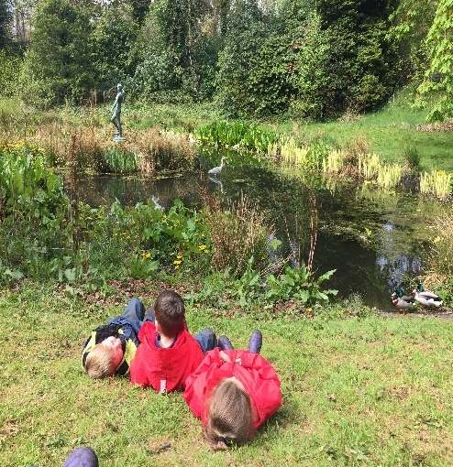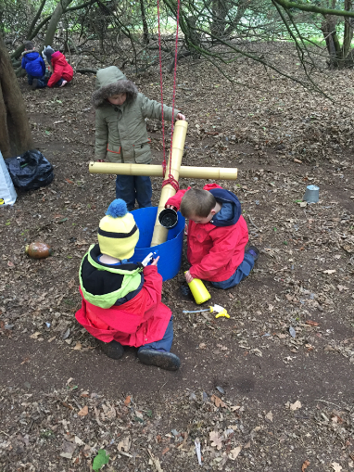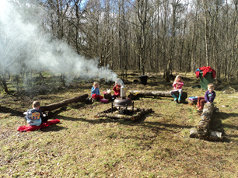

In these settings children are outdoors all of the time except in extreme weather conditions. Children and staff will have access to a sheltered area this could be a permanent or temporary structure. There may also be a meeting point, premises or a base camp used for the drop off and collection of children. These settings will have a comprehensive contingency plan which has been articulated and agreed with parents in the rare occasion where severe weather conditions prevent children from being outside.

**Settings**

Abriachan Forest School

Auchlone Nature Kindergarten

Bushcraft Bairns

Bonaly Forest Kindergarten

Cammo Forest Kindergarten

Corstorphine Hill Forest Kindergarten

Chapter One Childcare Dalkeith Treetops

Dalmahoy Woodland Family First Nurseries Limited

Drumfork Forest School and Out of School

Dunbar Private Nursery

Earthtime Elgin Forest School Nursery

Earthtime’s Forest School Nursery

Escape to the Story Outdoor Nursery

Evergreen Outdoor Nursery

FossoPLAY Outdoor Nursery

Forest Foxes Kindergarten

Greenhill Outdoor Nursery

Haddo Woodland Kindergarten

Hawkhill Forest Kindergarten

Hazelhead Park Outdoor Nursery

High Flyers @ The Woods

Kinder Croft CIC Outdoor Nursery

Lauriston Castle Forest Kindergarten

Little Bugs

Little Bugs Nursery

Little Bugs at Fordell Firs

MAKI Pups

Methilhill Nature Nursery

Mucky Boots

Newbattle Forest Kindergarten

Nurtured By Nature Kindergarten

Off Grid After School

Queensferry Forest Kindergarten

Riverside Cottage Nursery

Silver Birch Outdoor Nursery

Stramash Outdoor Nursery

Stramash Outdoor Nursery Tornagrain

Stramash Outdoor Nursery, Elgin

Stramash Outdoor Nursery, Fort William

Templars Park Outdoor Nursery Aberdeen

The Forest Nursery at Merchiston

The Nature Nursery Montessori Ltd

The Secret Garden Outdoor Nursery

Vogrie Outdoor Early Learning and Childcare

W.I.L.D. Forest School OSC

Wild Sparks

Wild Wellies Kindergarten Ltd

Willow Den at The Falkirk Wheel

Willow Den at Spartans

Woodland Play Ltd

Wonder Woods Woodland Nursery

Woodland Outdoor Kindergartens- Eastwood

Woodland Outdoor Kindergartens- West End

**Useful guidance**

Out to Play – Practical guidance for creating outdoor play experiences in early learning and childcare

<https://hub.careinspectorate.com/media/1289/out-to-play-creating-outdoor-play-experiences-for-children-practical-guidance.pdf>

My World Outdoors

<https://hub.careinspectorate.com/how-we-support-improvement/care-inspectorate-programmes-and-publications/my-world-outdoors/>

Early Learning and Childcare: Delivering High Quality Play and Learning Environments Outdoors

<https://hub.careinspectorate.com/media/1157/delivering-play-and-learning-environments-outdoors-practice-note.pdf>